

**AHSANULLAH UNIVERSITY OF SCIENCE AND TECHNOLOGY**

**Department of Electrical and Electronic Engineering**

**Project Report**

**Course No:** EEE-4154

**Course Name:** Power System II Lab.

**Project Title**: Optimum Power Control at Different Loading.

**Date of Submission**: 04/02/2023

**Submitted by:**

|  |  |
| --- | --- |
| Name | ID |
| **Md. Rahatin Rahman Niloy** | **190105045** |
| **Mohsin Islam Rifat** | **190105046** |
| **Anika Tahsin Afia** | **190105047** |
| **Md. Rudro Raihan** | **190105048** |
| **A.K.M. Aktaruzzaman Shuvo** | **190105050** |

Lab Section : A-2

Group : 03

Year : 4th

Semester : 1st

**Title of the project:**

Optimum Power Control at Different Loading

**Objective:**

In this project we have designed a optimum power control system at different loading situation. we designed a system that can deliver the required power to a load using Current injection device.

**Equipment:**

• 220V-6V Transformer

• 555 timer

• Resistors (10K,1K)

• Relay 6V DC

• Capacitors –(103pf,10uf,2pf,1000uf)

• Load (100W,60W,25W)

• Vero board

• Diode (1N4001)

• POT (500K ohm)

• Switch ,wires

• Current Injection device

• Variac

**Methodology:**

Power system loads vary constantly, which creates dynamic power regulation needs. The optimal operation of power systems is dependent on accurate and timely control of the operating parameters. A variety of power control techniques have been developed.We used current injection device to give the rated power to the load to keep the voltage rating 220V constant.

**Circuit Diagram:**

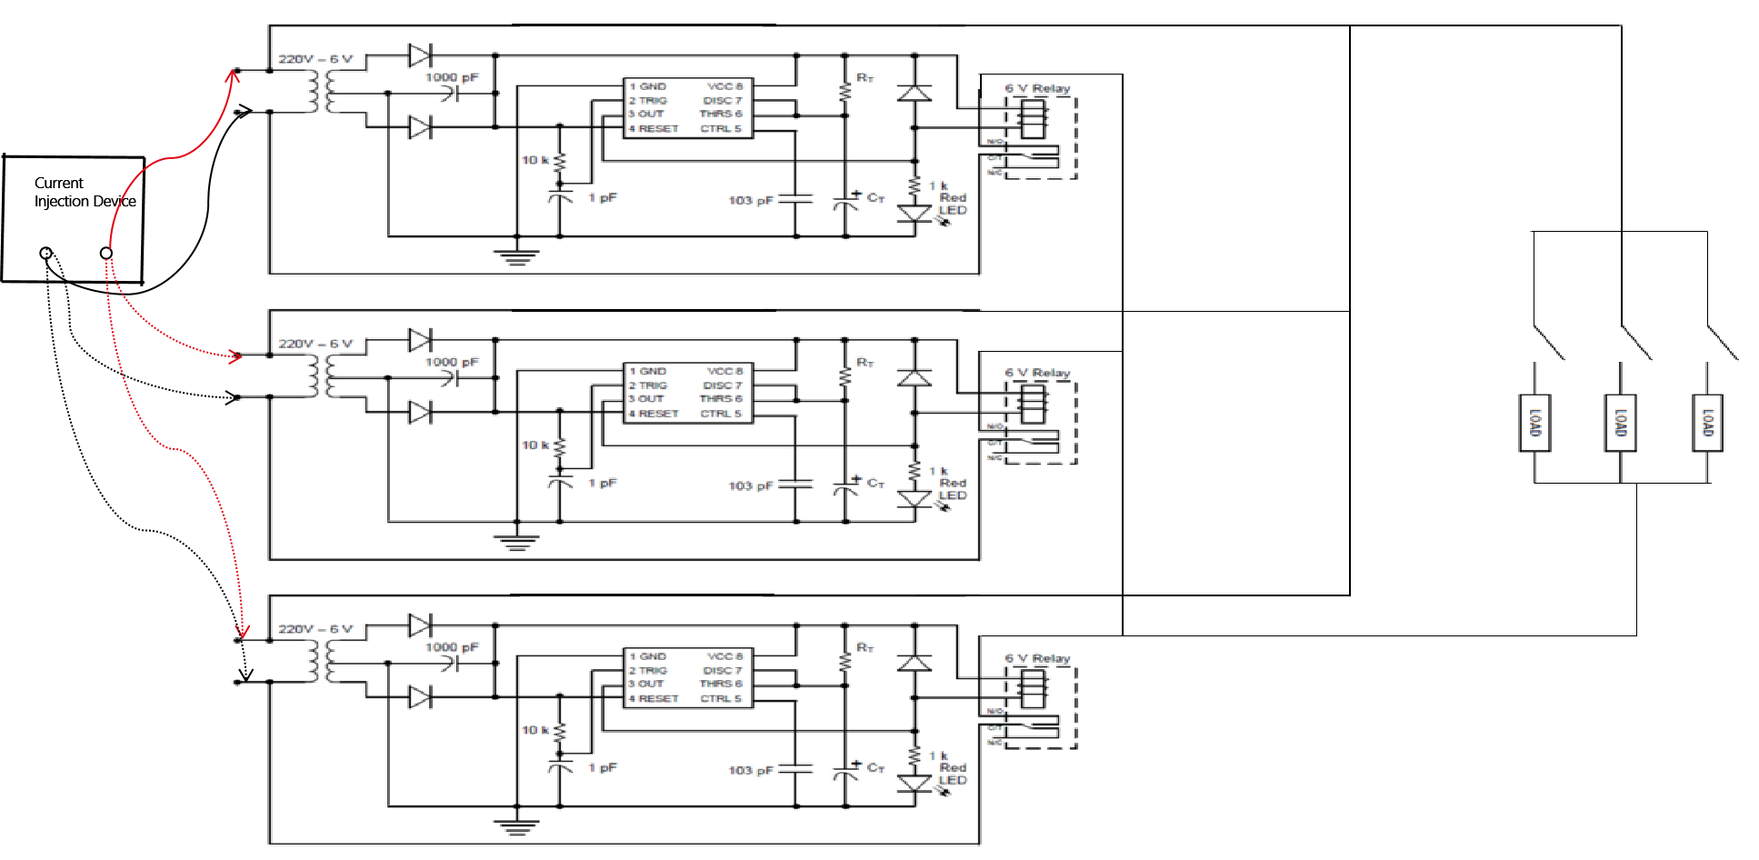

**Description of Elements:**

**Different current level :**

Here 220v is fixed supply to the load different rating current will inject across the load to fullfill their power rating at different loading condition .A current injection device is used to supply different current requirement.

**Timer circuit:**

We assumed 3 different loading condition in our project .So based on these loading condition the required power will be supplied. But we know Base Load power plant take some times to supply. For that, power will be supplied after that time delay.So,in our project timer circuit is used to make that delay .

**Relay:**

Relay is used in this project for switching operation. Every relay is controlled by a timer .Relay is initially off before meeting the time delay that is need to on the base laod power plant or other power station .After that delay, Relay becomes on.

**Working Principle:**

When AC main single phase supply comes to the step down centre tapped transformer, it convert voltage 6V AC. Two diode (1N4007) rectify and convert AC to DC. 555 timer use for generating the time delay. In this project consider three types of load. Such as base load,peak load and off-peak load. For base load consider 5 seconds time delay. Both peak and off-peak load consider 1 second time delay. Shorted normally open terminal of all 6v relay and connected to the one end of the load. Another terminal of the load is connected to the main AC power supply live line. Here we use three different rating load. Such as 60 watt(base load), 100watt(off-peak load) and 200 watt(peak load).

In this project, we keep the voltage rating 220V constant. Consider step down transformer-1 and timer circuit for base load. Similarly transformer-2 for off-peak and transformer-3 for peak load. When 220V comes from main supply to the transformer-1, timer circuit gives 5 seconds delay then current flow through the relay. Then the relay is energized and 60watt load is connected if press the switch. We measure the current across the load using clamp meter. If current is less than the load rating current then use current injection device to give the rated current to the load. So that we give the load rated power. Similar operation also happen for transformer-2 and transformer-3, only difference is generate time delay.

**Application:**

* By using this project concept consumer can get rated power across the loads. So that consumer loads component life time can be longer.
* In power plant, this can build a bridge between generation end to consumer end.

**Discussion:**

By using pot resister we give the time delay to the timer circuit. To give our require time delay 5 seconds, need resistor value 455 KΩ using the calculation (Ʈ = RtXCt). We give this 455 KΩ using pot but the timer curcit did not give the exact time delay. When we increase the value of resistor then we found our desire output.

**Conclusion:**

This type of system can be used in households and distribution centers. To use it properly some modification must be made. In upcoming future, the modification version of this project can be used in several electrical system. This project can be said both economic and efficient.

**Future Work**

•With cylic design we can automate the power system with peak load off peak load and Base load situation.

•The optimum power control system could be integrated with smart grid technologies to improve the overall performance and reliability of the power grid.

•The optimum power control system could be designed to incorporate renewable energy sources, such as wind and solar power, to make the power grid more sustainable and eco-friendly.

•Further research could be conducted to study the effect of different load patterns on the performance of the optimum power control system and how it can be optimized for different scenarios.

**Contribution:**

**Md. Rahatin Rahman Niloy (Id:190105045):**

* Worked on time delay measurement.

**Mohsin Islam Rifat(ID:190105046):**

* Designed the circuit diagram.
* Worked on soldering.
* Idealization and helping to shape the overall direction of the project.
* Identifying obstacles that arise during the project and finding solution to overcome them.

**Anika Tahsin Afia (Id:190105047):**

* Worked on presentation slide and presentation script.

**Md. Rudro Raihan(ID:190105048):**

* Listed all the equipment from the circuit diagram, bring all of them for the project and ensuring that they are use efficiently.
* Overseeing the overall progress of the project and ensuring that it stays on track.

**A.K.M Aktaruzzaman Shuvo (Id:190105050)**

* Worked on soldering.